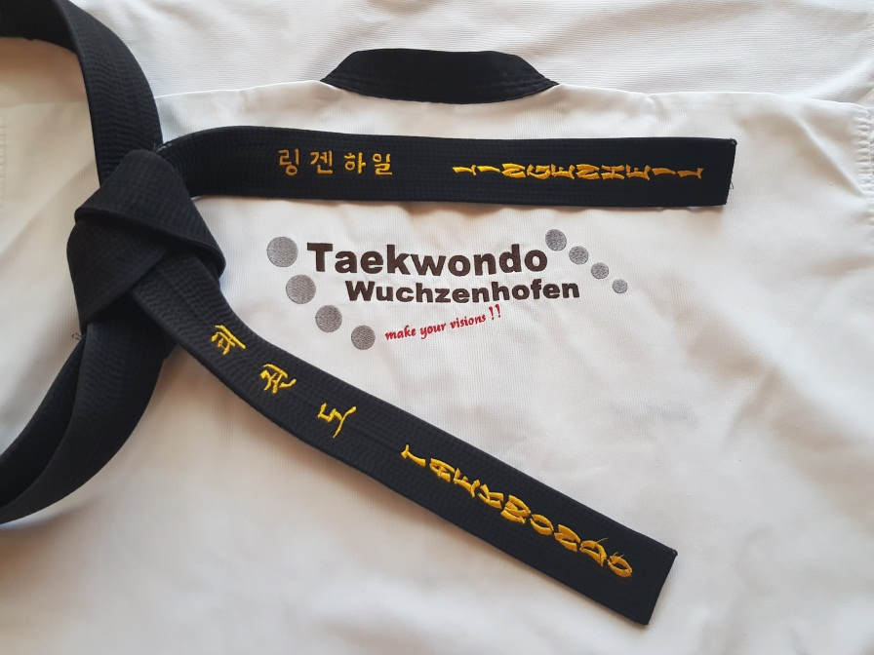

Ansprechpartner

Ludwig Lingenheil Nina Lingenheil Thomas Walke Tim Lingenheil
3. Dan TKD 1. Dan TKD 1. Dan TKD 2. Kup TKD
Tel. 07561 7989 Handy 0041789224166
Handy 015209884568

www.tkd-wuchzenhofen.de

